FAMU - FSU COLLEGE OF ENGINEERING

Senior Design I

*Professors:*

Dr. Jerris Hooker

Dr. Shayne McConomy

Inserting image...

Concept Generation

Inserting image...

*Authors:*

Denis Dineen

Jacob Hutto

Hunter Kramer

Doran McFalls

Nicolas Palmeiro

*Date:*

October 18th, 2019



# **Concept Generation**

Using multiple idea generation techniques – including morphological charts, biomimicry, and group brainstorming – our team was able to develop 100 unique possible project concepts. All 100 concepts, as well as overview(s) of the concept generation tools, are located within the appendix. From the complete set, we selected eight concepts we believed to be most feasible given the parameters of the project scope. These eight medium-fidelity concepts expanded on details such as material selection, positive aspects, and potential issues. Our team then selected three ideas from the medium-fidelity list as our high-fidelity concepts. We believe that our medium and high-fidelity concepts satisfy the mission critical targets previously discussed. Explanations of the medium and high-fidelity are listed below.

## **Medium Fidelity Concepts**

### Double Robotic Arms

The double robotic arm is a very versatile concept. This concept allows for the most maneuverability as it utilizes two arms, both with multiple joints. The end of the joints are equipped with pinchers that are good for gripping on to things and can then be maneuvered in multiple ways. These arms will most likely be fabricated out of aluminum, as it is light and strong. The arms will be hard wired to the truck for power, allowing for extended use and no dependency on a battery or solar. The arm will be controlled via Bluetooth from the ground which helps distance the worker from the danger. The worker will be able to view their work via a camera feed that will be focused on the ends of the arms. The arms will be attached to a base or directly to the bucket of the truck. While these arms allow for the most maneuverability, they will require the most complicated control scheme.

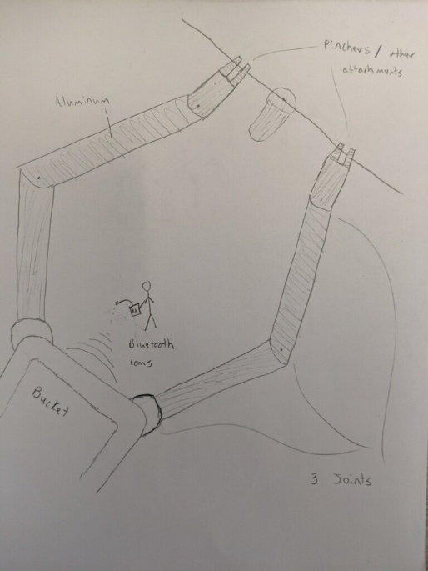

### Bucket Mounted Robot with Shotgun Stick

This concept uses a single robotic arm with a shotgun stick attachment. A drone camera would be mounted to the arm and the operator would view the video feed from a screen on the ground. The operator would control the drone with an RC controller using radio signals. The attachment would be fiberglass and the arm itself would be steel. Since fiberglass is non-conductive, no additional ground would be required. It would also separate the operator from the energized line. The drawback to this concept is that what it could do would be very limited. This is because the attachment can only probe hot taps on a current transformer and operate switches.

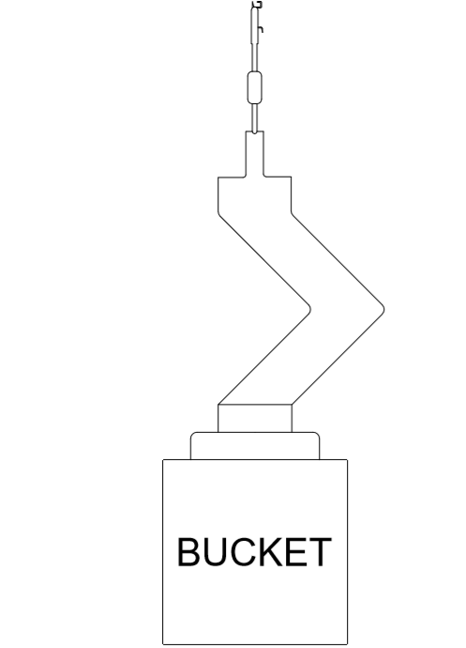

### Drone with Attached Arms

This concept integrates a robotic arm attachment onto a standard camera drone. The arm would be able to perform the basic repair movements while the mounted camera could be utilized for video training purposes. The system would be controlled remotely by an onsite line worker. It would be constructed from PVC material and run off an external battery source. Advantages of the concept include high maneuverability, previously installed lights and cameras, and GPS localization. One concern would be the limited run time of the device due to its reliance on battery power. A second concern is the limited range of data transfer rate of Bluetooth and audio transmission systems.

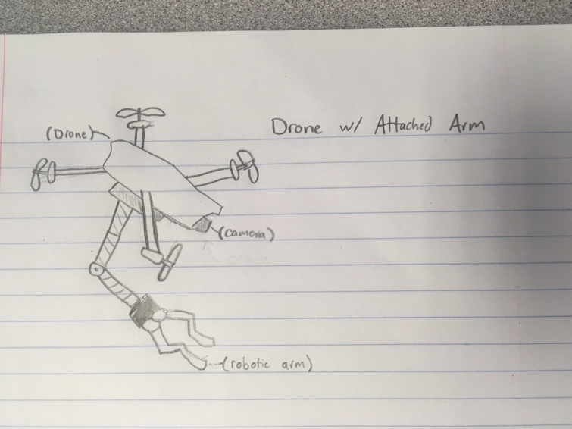

## Double-Sided Hook Robot

The double-sided hook concept incorporates two coiled rods on the sides of the robot to manipulate the necessary wires. The robot would be connected to a base block and perform translation through two separate track belts. The base block would also have a single line of rotation in order to change the angle at which the device could approach live wires. The end of the coil rod “hooks” could be made from insolated material to prevent damage caused by live wire voltages. One concern for the hook robot is that it does not provide the same degrees of freedom/fluid motion as other medium fidelity concepts discussed in this section. Another concern would be incorporating a camera that could adjust to the translation and rotation movements of the robot/base block.

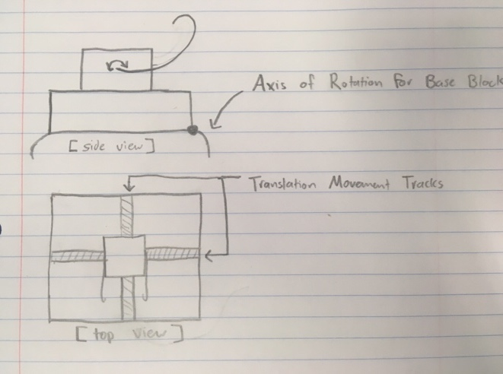

## Rotating claw within frame

This robot will have a C shaped claw that will have the powerline fit into one of its sides. The line will enter through the outer shell into the inner shell where it will be clamped by the linear actuator. The outer shell will rotate causing the exterior wire to unravel, releasing the conductor from the insulator. Then the mechanism will return to a position such that the claw can be removed from the conductor.

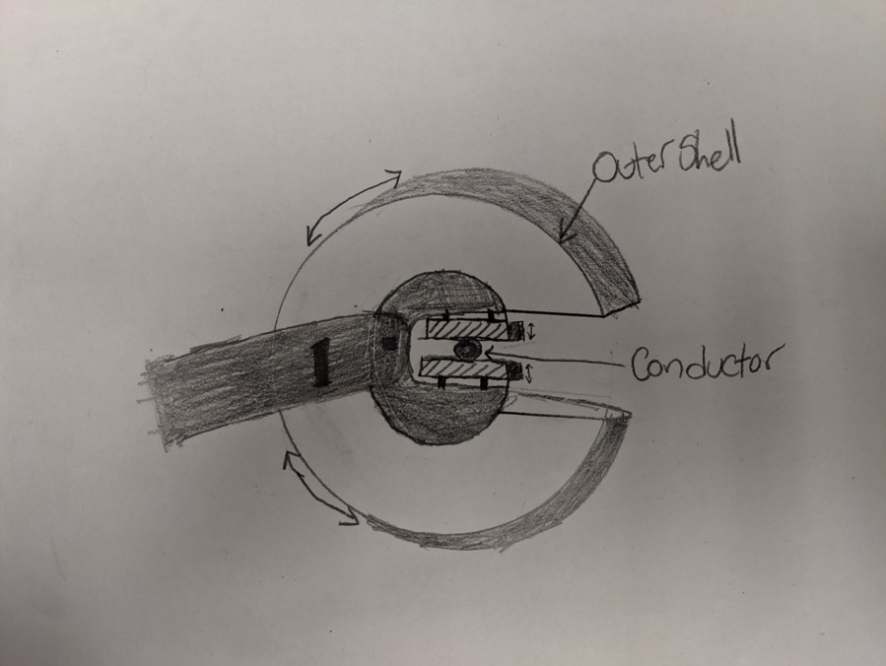

### Serrated Edge/Claw Arm

For this concept, the robot will be equipped with a single arm that will have a retractable serrated knife and a claw machine for grasping. This tool would be used for the sole job of removing the securing wire from the conductor-insulator connection for the insulator replacement process. A guard could be added to the edge of the knife to ensure there would be no collateral damage to the conductor or insulator. This would benefit the project since the removal of this wire poses significant threat to the workers. The specificity of this design is both a good and bad thing, it can be good at one job, but it wouldn’t be able to be expanded into other tasks that pose threats to linemen.

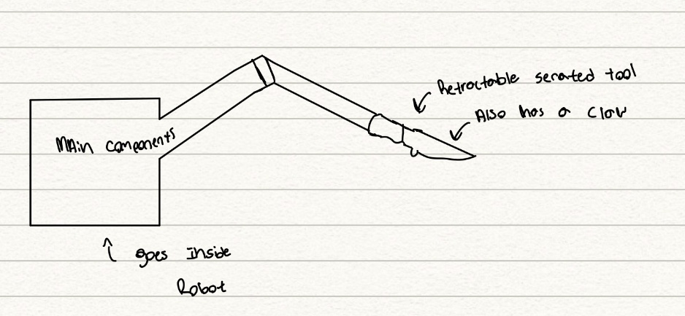

## **High Fidelity Concepts**

### Line Suspended Robot

The line suspended concept is very similar to line inspection robots that use wheels to navigate across powerlines. The main difference with this concept is the addition of a robotic arm to be used for the many functions our project entails. The robot will be made from aluminum to provide a rigid body but not as heavy as other more durable metals as excess weight can damage the conductors. The robot will be battery powered, as the robot will be separated from the trucks bucket it would be impractical to have a wire running to it to provide power therefore battery would be the most effective choice. The robot will be controlled with a Bluetooth controller to provide enough inputs for all the operations it will be capable of doing. Four VR cameras will be spaced around the four corners of the robot and used for depth, view, and movement similar to HTC Vive. The robotic arm will have several attached tools at its disposal to cover the main functions required.

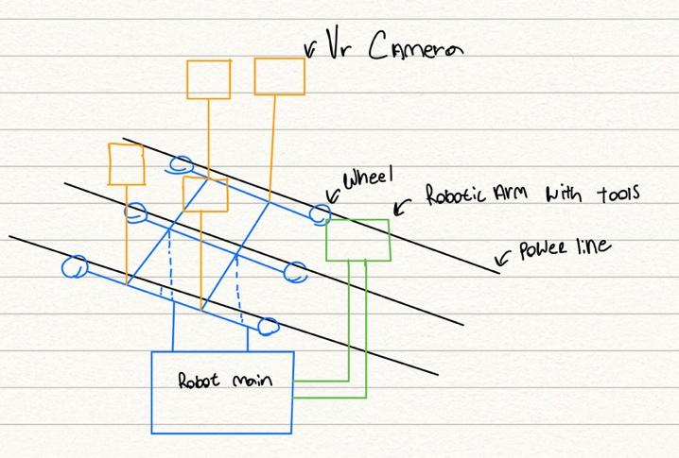

### Modular Arm with Attachments

The concept for a modular robotic arm solves quite a few issues. With a limited time and budget, it is unlikely the team will be able to create a robot that can fully execute all the tasks that linemen are required to do. The modular arm allows the team to begin solving the total problem one task at a time. Different tools can be designed and added as research on the product develops but also allows for a solution to at least a few problems more immediately. The arm itself utilizes a system of channel locks to firmly attach each tool while also making attachment and release of the tools simple. The attachment and removal of each tool could either be done by the user on the ground or automatically by the robot at the line if the tools are located within the bucket. Electrical connections for each attachment will be conveniently located at the end of the arm and on top of each attachment such that when the channel locks are in the fully locked position, power is transmitted to the tool for operation. Each tool could also have an identification code embedded in the top to communicate back to the which tool it is connected to since the control system will need to be modified to work for each individual tool. The benefits of this arm are that the startup cost for this sort of solution would be relatively low as compared to a robotic arm that has full maneuverability since each tool could be added on as money becomes available and that each tool would be finely tuned to complete whatever task is being done. One drawback to this design would be the difficulty with changing out tools during the operation of the robot and with having open electrical connections that close to the energized line.

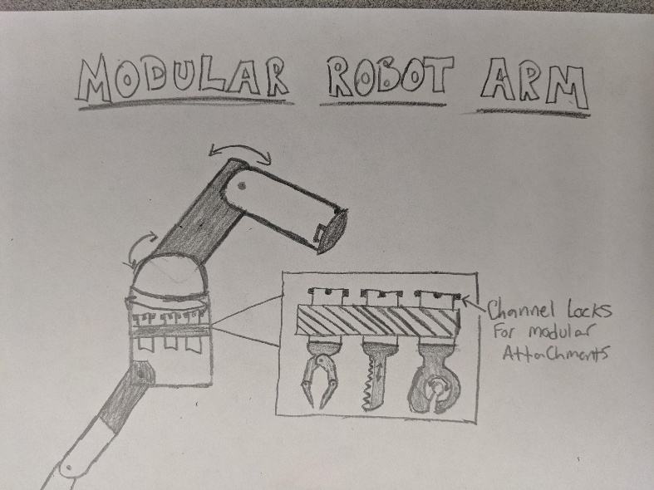

### Serrated Edge/Claw Arm

For this concept, the robot will be equipped with a single arm that will have a retractable serrated knife and a claw machine for grasping. This tool would be used for the sole job of removing the securing wire from the conductor-insulator connection for the insulator replacement process. A guard could be added to the edge of the knife to ensure there would be no collateral damage to the conductor or insulator. This would benefit the project since the removal of this wire poses significant threat to the workers. The specificity of this design is both a good and bad thing, it can be good at one job, but it wouldn’t be able to be expanded into other tasks that pose threats to linemen.



Our medium and high-fidelity concepts will be incorporated into the next step of our design process – concept selection. They will be evaluated on how well they demonstrate the engineering characteristics we defined as mission critical.

Appendix

Morphological Chart:

|  |  |  |  |  |  |
| --- | --- | --- | --- | --- | --- |
| Operate with High Voltages | Training software | Communication to device | Use different power sources | Uses light | Records video/Audio |
| PVC | Unity VR | Bluetooth | Battery | LED headlights | Camera mount |
| Plexiglass | Unreal VR | Wifi | Truck Power | flashlights | Built in camera |
| Wood | AR simulations | Wired | Solar | Headlamps |  |
| Aluminum w/ insulation | Training course |  |  | Infrared camera |  |
| Fiberglass |  |  |  |  |  |

Morphological Chart Concepts:

|  |  |
| --- | --- |
| Concept # | Description |
| 1 | PVC- Unity-BT-Battery-LED headlights-camera mount |
| 2 | PVC- Unreal-BT-Battery-LED headlights-camera mount |
| 3 | PVC- Unity-WIFI-Battery-LED headlights-camera mount |
| 4 | PVC- Unity-BT-Truck-LED headlights-camera mount |
| 5 | PVC- Unity-BT-Battery-Flashlight-camera mount |
| 6 | PVC- Unity-BT-Battery-LED headlights-built in camera |
| 7 | PVC- Unreal-WIFI-Battery-LED headlights-camera mount |
| 8 | PVC- Unreal-BT-truck-LED headlights-camera mount |
| 9 | PVC- Unreal-BT-Battery-Flashlight-camera mount |
| 10 | PVC- Unreal-BT-Battery-LED headlights-built in camera |
| 11 | Fiberglass- Unity-BT-Battery-LED headlights-camera mount |
| 12 | FIberglass-Unreal-WIFI-Truck power-Flashlights-Built in camera |
| 13 | FIberglass- AR simulations-Wired-Solar-Headlamps-Camera mount |
| 14 | FIberglass- AR simulations-Wired-Solar-Headlamps-built in camera |
| 15 | FIberglass- training course – BT-Battery- LED Headlights – Camera mount |
| 16 | FIberglass- training course – WIFI-Truck power-Flashlights-Built in camera |
| 17 | Aluminum w/ insulation- Unity-BT-Battery-LED headlights-camera mount |
| 18 | Aluminum w/ insulation- training course – BT-Battery- LED Headlights – Camera mount |
| 19 | Aluminum w/ insulation- training course – WIFI-Truck power-Flashlights-Built in camera |
| 20 | Aluminum w/ insulation- training course – Wired-Solar-Headlamps-Camera mount |
| 21 | Aluminum w/ insulation- Unity-WIFI-Battery-LED headlights-camera mount |
| 22 | Aluminum w/ insulation- Unity-BT-Solar-LED headlights-camera mount |
| 23 | Aluminum w/ insulation- Unity-BT-Solar-LED headlights-built in camera |
| 24 | Aluminum w/ insulation- AR-BT-Battery-LED headlights-camera mount |
| 25 | Aluminum w/ insulation- AR-BT-Battery-LED headlights- built in camera |
| 26 | Aluminum w/ insulation- Unity-BT-Truck power-LED headlights-camera mount |
| 27 | Aluminum w/ insulation- Unity-BT-Truck power-LED headlights- built in camera |
| 28 | Aluminum w/ insulation- Unity-BT-Battery-IR camera-camera mount |
| 29 | Aluminum w/ insulation- Unity-BT-Battery-IR camera- built in camera |
| 30 | Aluminum w/ insulation- Unity-BT-Battery-Headlamps-camera mount |
| 31 | Wood-Unity-Wired-Solar-Headlamps-Camera mount |
| 32 | Wood- Unreal-Wired-Solar-Headlamps-Camera mount |
| 33 | Wood- AR simulations-WIFI-Solar-Headlamps-Camera mount |
| 34 | Wood- AR simulations-BT-Solar-Headlamps-Camera mount |
| 35 | Wood- AR simulations-Wired-Battery-Headlamps-Camera mount |
| 36 | Wood- AR simulations-Wired-Truck power-Headlamps-Camera mount |
| 37 | Wood- AR simulations-Wired-Solar-LED headlights-Camera mount |
| 38 | Wood- AR simulations-Wired-Solar-Flashlights-Camera mount |
| 39 | Wood- AR simulations-Wired-Solar-IR Camera-Camera mount |
| 40 | Wood- AR simulations-BT-Solar-IR Camera-Camera mount |
| 41 | Plexiglass-Unreal-WIFI-Truck power-Flashlights-Built in camera |
| 42 | Plexiglass-Unity-WIFI-Truck power-Flashlights-Built in camera |
| 43 | Plexiglass-Unreal-BT-Truck power-Flashlights-Built in camera |
| 44 | Plexiglass-Unity-BT-Truck power-Flashlights-Built in camera |
| 45 | Plexiglass-Unreal-WIFI-Solar-Flashlights-Built in camera |
| 46 | Plexiglass-Unity-WIFI-Battery-Flashlights-Built in camera |
| 47 | Plexiglass-Unreal-BT-Solar-Flashlights-Built in camera |
| 48 | Plexiglass-Unity-BT-Battery-Flashlights-Built in camera |
| 49 | Plexiglass-Unreal-WIFI-Solar-LED headlights-Built in camera |
| 50 | Plexiglass-Unity-WIFI-Solar-LED headlights-Built in camera |
| 51 | Plexiglass-Unreal-WIFI-Truck power-Flashlights- Camera mount |
| 52 | Plexiglass-Unity-WIFI-Truck power-Flashlights- Camera mount |
| 53 | Plexiglass-Unity-BT-Truck power-Flashlights- Camera mount |
| 54 | Plexiglass-Unreal-WIFI-Solar-Flashlights- Camera mount |
| 55 | Plexiglass-Unity-WIFI-Battery-Flashlights- Camera mount |
| 56 | Plexiglass-Unreal-BT-Solar-Flashlights- Camera mount |
| 57 | Plexiglass-Unity-BT-Battery-Flashlights- Camera mount |
| 58 | Plexiglass-Unreal-WIFI-Solar-LED headlights- Camera mount |
| 59 | Plexiglass-Unity-WIFI-Solar-LED headlights- Camera mount |
| 60 | Plexiglass-Unreal-BT-Solar-LED Headlights- Camera mount |

Biomimicry Concepts:

|  |  |  |  |
| --- | --- | --- | --- |
| Concept # | Animal | Quality | Relation to Project |
| 61 | Snake | Tree Climbing | Robot that wraps around pole to climb |
| 62 | Bear | Tree Climbing | Robot that clamps on to the pole and climbs |
| 63 | Bird/Squirrel | Walking on energized lines | Robot that uses the ability to not cross high potentials to safely operate on powerlines |
| 64 | Elephant | Trunk | Robotic arm that uses a simulated musculature to manipulate itself |
| 65 | Giraffe | Neck | Robot that is extended on a long boom like a giraffe's neck. |
| 66 | Human | Arms | Simulate human arms since that is what is currently doing these jobs |
| 67 | Eel | Skin | Robot that can electrically insulate from environment |
| 68 | Monkey | Vine Swinging | Robot that swings across power lines for operation |

Group Brainstorming Concepts:

|  |  |
| --- | --- |
| Concept # | Description |
| 69 | Doctor Octopus arms |
| 70 | Soft robotic hands |
| 71 | Four-armed Robot |
| 72 | Telescopic stilts on robot |
| 73 | Arms attached to bucket with passenger in bucket |
| 74 | Robot on the line that mechanically wraps/unwraps wires |
| 75 | Robot with reciprocating saw that cuts old wires off |
| 76 | Robot that uses a different method of attaching conductor to insulator |
| 77 | Off-the-Shelf robot arm with tuned control systems |
| 78 | Fived-Armed Robot |
| 79 | Robot that simply holds equipment for the lineman to access |
| 80 | Robot that clamps onto a line and uses wheels to translate |
| 81 | Robot that is fixed permanently to the line for automated work or inspection |
| 82 | Switch to underground utilities |
| 83 | Robot that drops from a helicopter to operate on lines |
| 84 | Rock Climber Robot |
| 85 | Swiss Army Knife Robot Hands |
| 86 | Six-Armed Robot |
| 87 | De-energizer Robot |
| 88 | Wire Fishing Robot |
| 89 | Propeller Blade Robot Hands |
| 90 | Grappling Hook Robot |
| 91 | Harpoon Gun Robot |
| 92 | Bi pedal Robot |
| 93 | Escalator Robot System |
| 94 | Lego Robot |
| 95 | Three-armed Robot |
| 96 | Wheeled pole Climber |
| 97 | Singular Robotic Arm |
| 98 | Sky Camera Robot with Arms |
| 99 | Seven-Armed Robot |
| 100 | Fully Autonomous Robot |